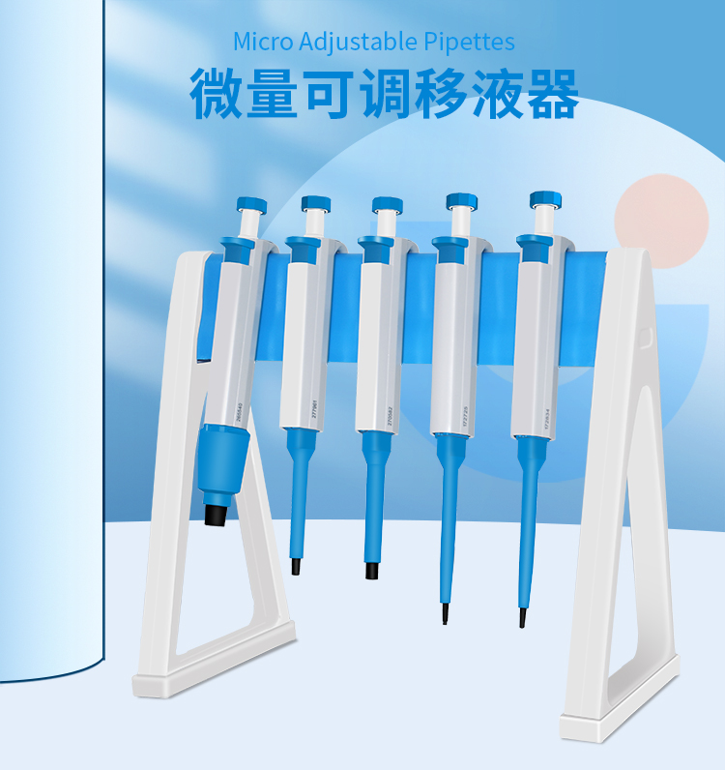
1、产品特点
HYD系列半支消毒手动单道可调式移液器
- 人体学的手柄挂钩设计, 可轻松挂靠在手掌上；
- 管嘴弹出按钮设计轻巧；
- 清晰的显示读数窗口；
- 管嘴推出器可拆卸，可高温高压消毒，便于清洗和保养；
- 备有配套的移液器挂钩、拆卸工具。

- 技术参数
型号 | 量程 | 测试点 | 准确度≤ | 精确度≤ | 增量
HYD-0.1B | 0.1-2.5ul | 2.5  1.25  0.25 | ±2.50%  ±3%  ±12% | ±2.0%  ±3.0%  ±6.0% | 0.05ul
HYD-0.5B | 0.5-10ul | 10  5  1 | ±1.00%  ±1.5%  ±2.5% | ±0.8%  ±1.5%  ±1.5% | 0.1ul
HYD-2B | 2-10ul | 20  10  2 | ±0.90%  ±1.2%  ±3.0% | ±0.4%  ±1.0%  ±2.0% | 0.5ul
HYD-5B | 5-50ul | 50  25  5 | ±0.60%  ±0.9%  ±2.0% | ±0.3%  ±0.6%  ±2.0% | 0.5ul
HYD-10B | 10-100ul | 100  50  10 | ±0.80%  ±1.0%  ±3.0% | ±0.15%  ±0.4%  ±1.5% | 1ul
HYD-20B | 20-200ul | 200  100  20 | ±0.60%  ±0.8%  ±3.0% | ±0.15%  ±0.3%  ±1.0% | 1ul
HYD-100B | 100-1000ul | 1000  500  100 | ±0.60%  ±0.7%  ±1.5% | ±0.2%  ±0.25%  ±0.7% | 5ul
HYD-1000B | 1-5ml | 5000  2500  1000 | ±0.5%  ±0.6%  ±0.7% | ±0.15%  ±0.3%  ±0.3% | 50ul
HYD-1WB | 1-10ml | 10  5  1 | ±0.6%  ±0.8%  ±3.0% | ±0.2%  ±0.3%  ±0.6% | 0.1ml

